**Branch: - Computer Science and Engineering Class: - III Year**

**Subject: - C-Skill Lab-IV Sem: - VI**

**Teacher Manual**

**PRACTICAL NO. 8**

**Aim:** Install and configure Jenkins with AWS for DevOps.

[Jenkins](https://jenkins.io/) is an open-source continuous integration tool written in Java. It provides custom integration services for software development. It is a server-based system used by many development teams. Jenkins allows integrating building, deploying and testing onto various environments, while reducing wait times for your development teams. DevOps Jenkins is a tool which is used to integrate and deploy the code between multiple applications. It integrates the code from Git repository and deploys through cloud services into another application.AWS provides reliable, scalable, and secure infrastructure resources that are ideal for running applications such as Jenkins. By running Jenkins on AWS compute, user only pay for what it use and can scale capacity up or down to match specific needs.

**Prerequisites:**

1. An**AWS account.**
2. An Amazon EC2 key pair.

**Steps:**

1. **Launching an Amazon EC2 instance**

To launch an EC2 instance:

* Sign in to the the [AWS Management Console](https://console.aws.amazon.com/ec2/).
* Open the Amazon EC2 console by selecting EC2 under Compute.
* From the Amazon EC2 dashboard, select Launch Instance.

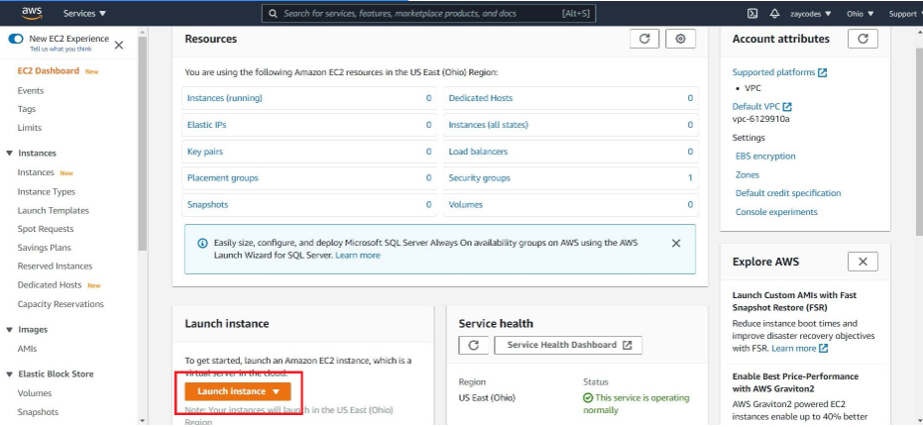

* The Choose an Amazon Machine Image (AMI) page displays a list of basic configurations called Amazon Machine Images (AMIs) that serve as templates for your instance. Select the HVM edition of the Amazon Linux AMI.

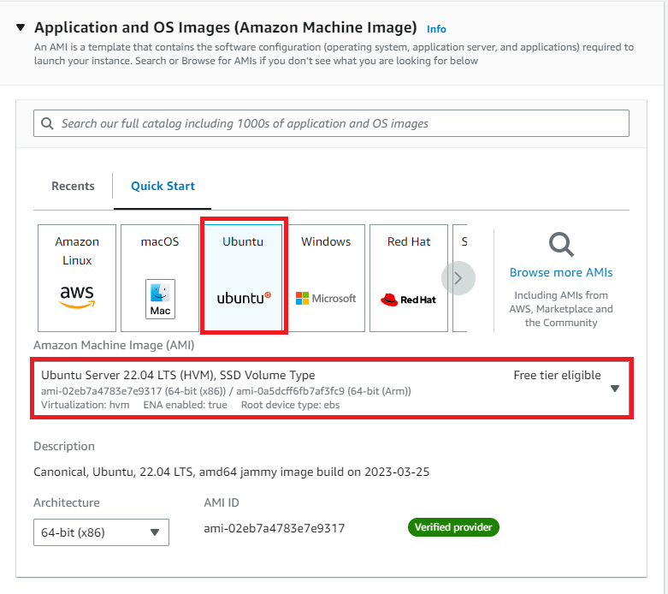

* Scroll down and create the key pair and launch instance.

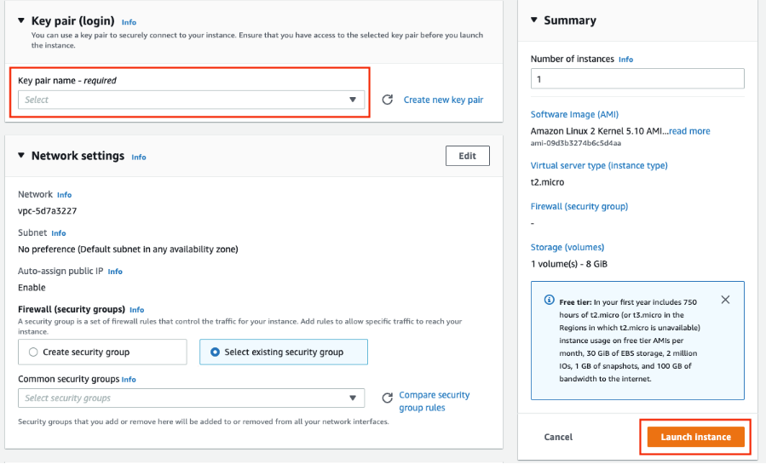

1. **Connecting to Linux instance.**

* Before you connect to your instance, click on instance and then click on security tab at the bottom bar.

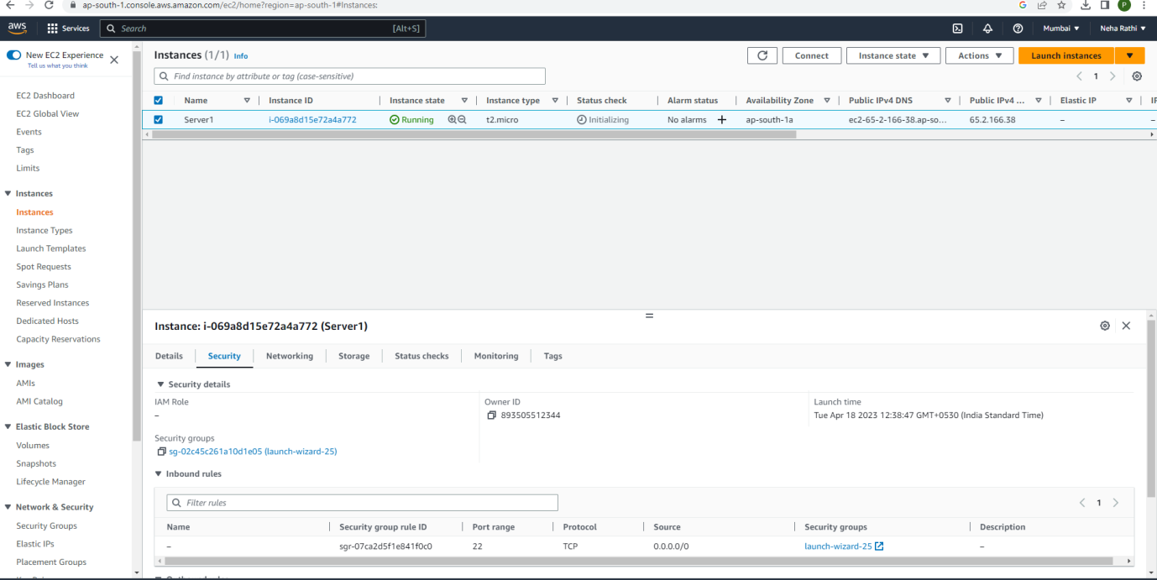

* Click on security groups and change inbound rules.Add rule which allows all traffic from internet and save it.

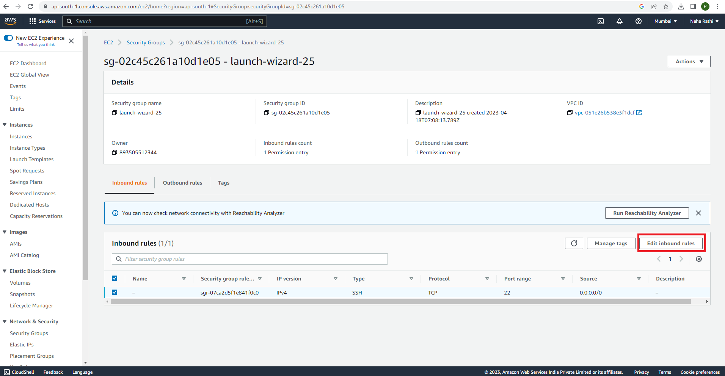

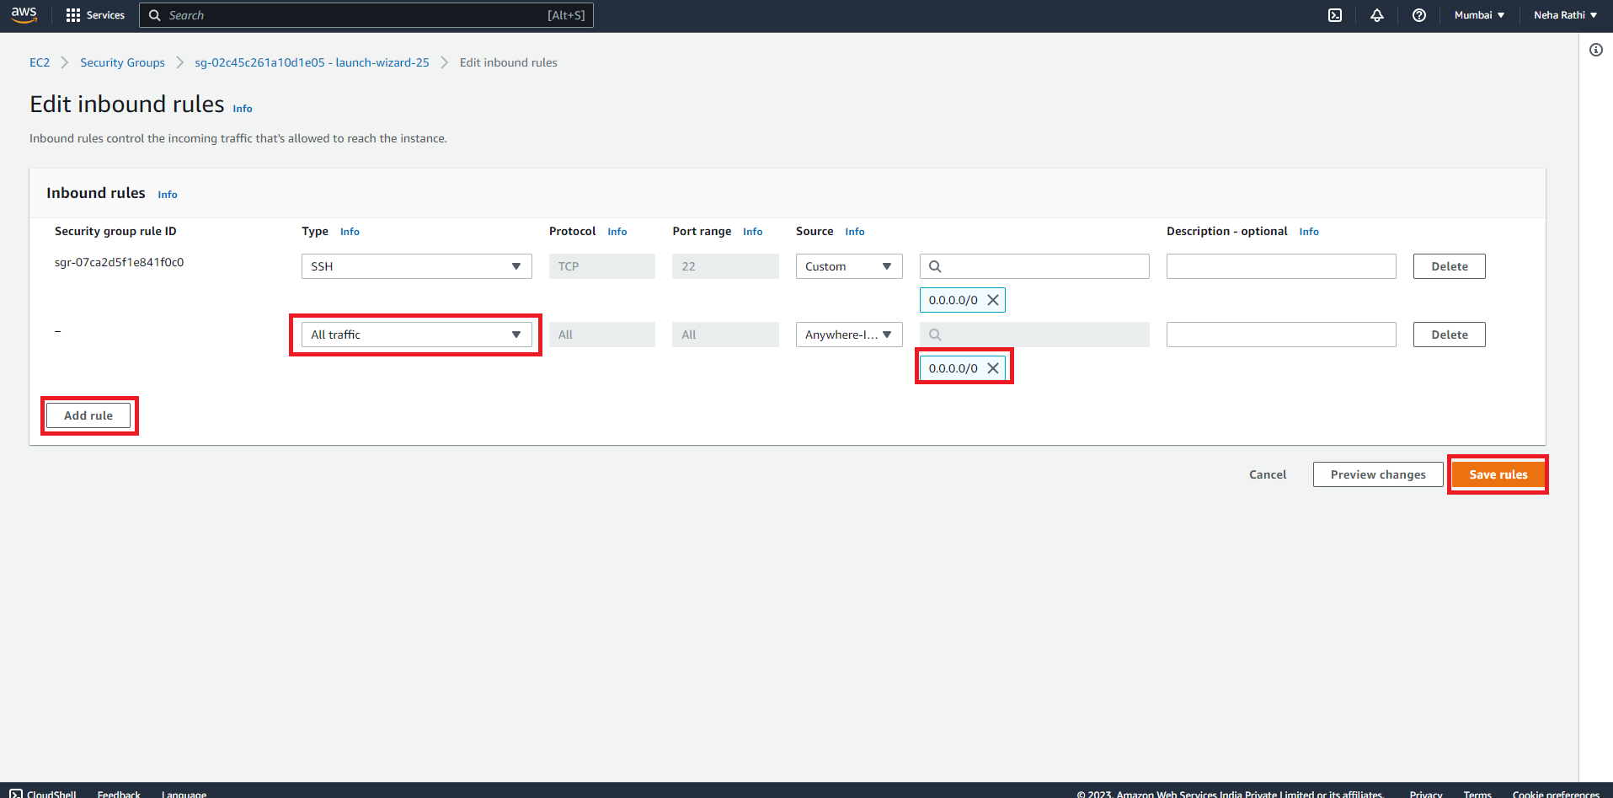

* Select an instance and click on connect. Switch to the tab SSH client and copy the URL for connection.

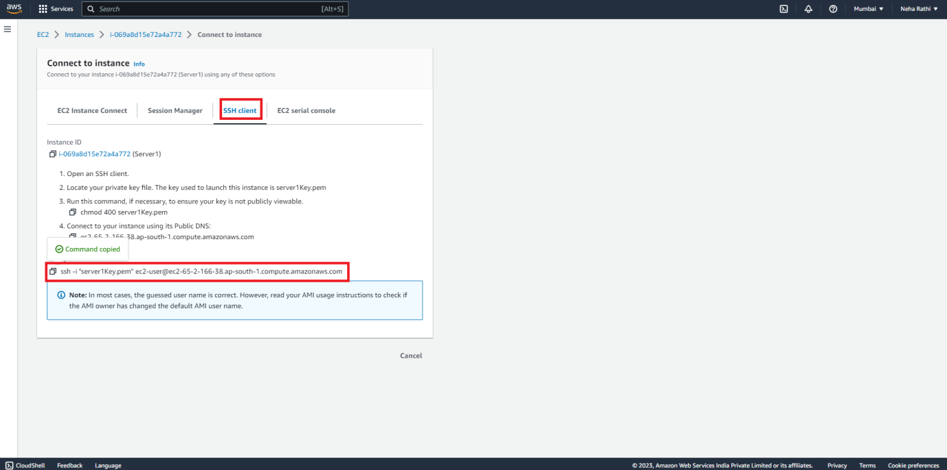

1. **Create a folder on desktop and copy .pem file in this folder. Right click in this folder and select “git bash here”.**

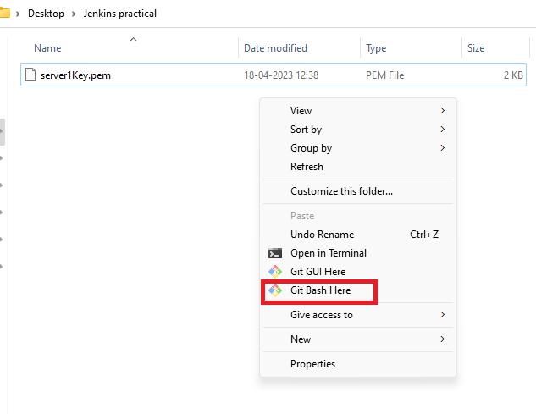

1. **Paste the path copied in step 2.**

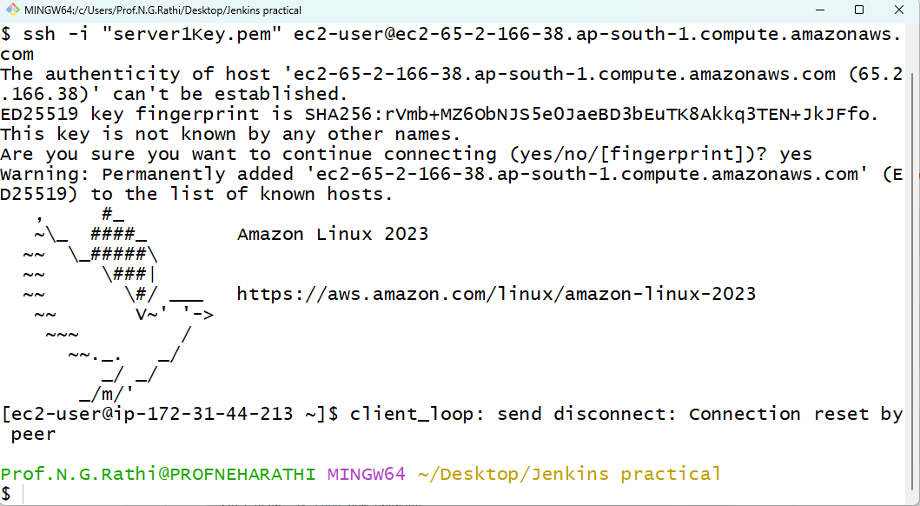

1. **Downloading and installing Jenkins**.

* Ensure that software packages are up to date on instance by using the following command to perform a quick software update:

sudo apt update

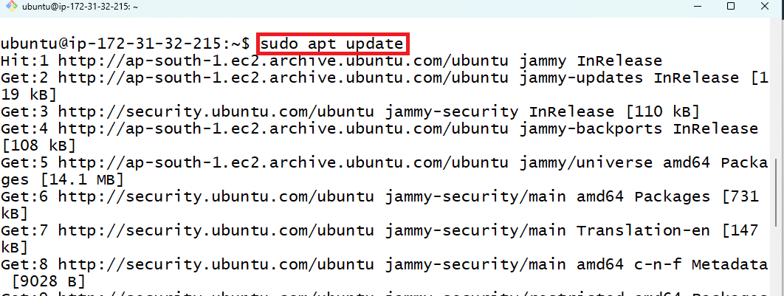

* Install Java using following command.

sudo apt .install openjdk-11 -y



* Check java installed or not using following command.

java -version

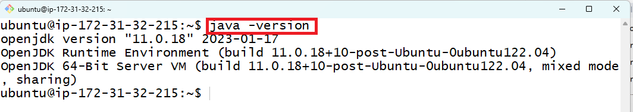

* Install Git and Maven using following command.

sudo apt-get install -y git maven

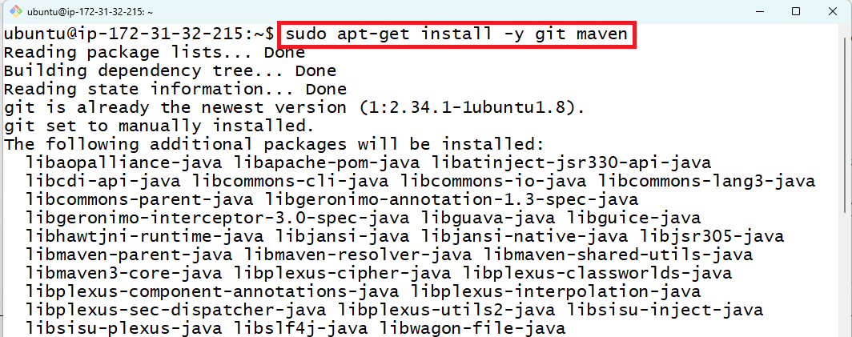

* Check git and maven installation.

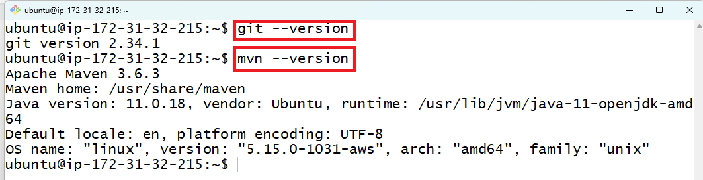

* Open website “https://www.jenkins.io/download/” and copy address of Jenkins 2.387.2 LTS .war file.

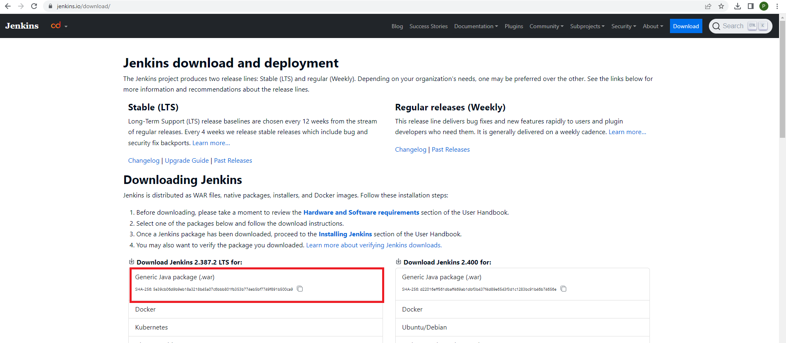

* Paste this address on gitbash by writing following command.

wget “https://get.jenkins.io/war-stable/2.387.2/jenkins.war”

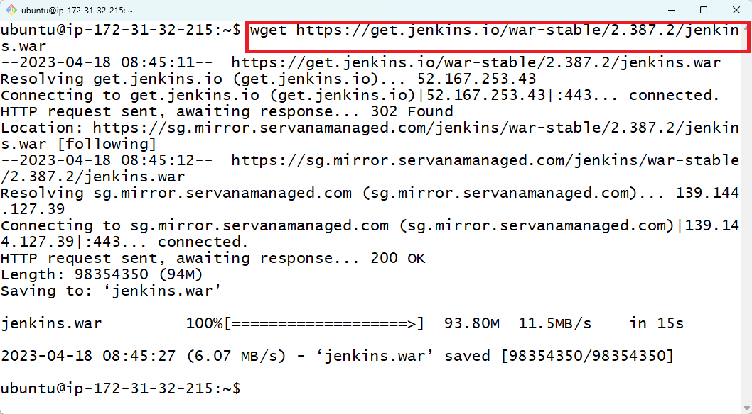

* Run Jenkins on EC2 instance using following command

java -jar jenkins.war

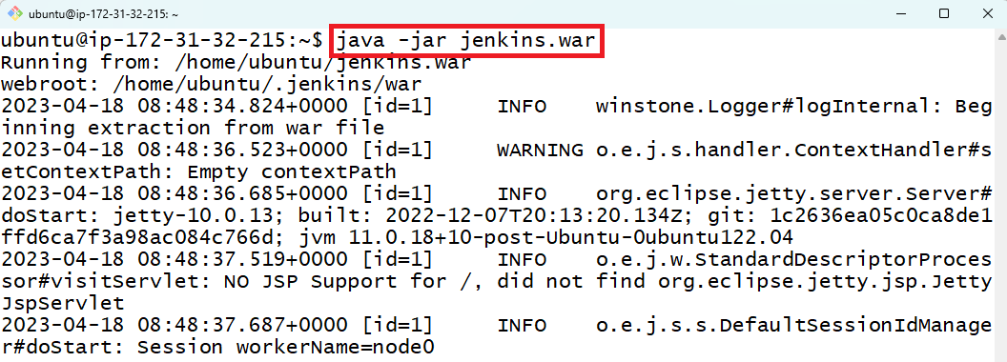

* Copy Public IPv4 Address and open it with port no. 8080.

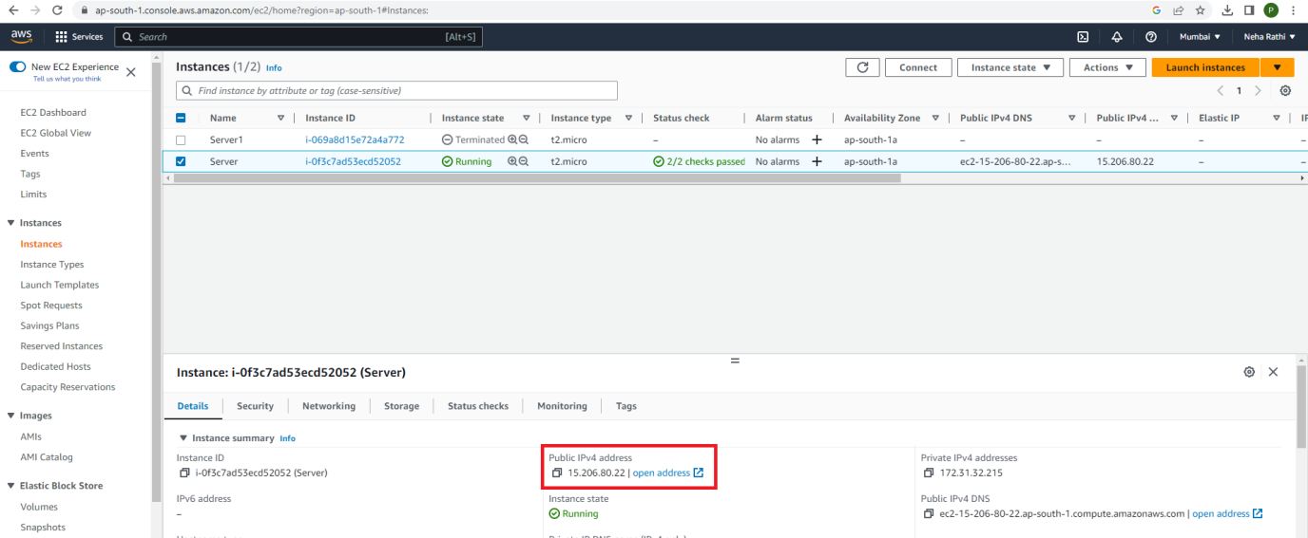

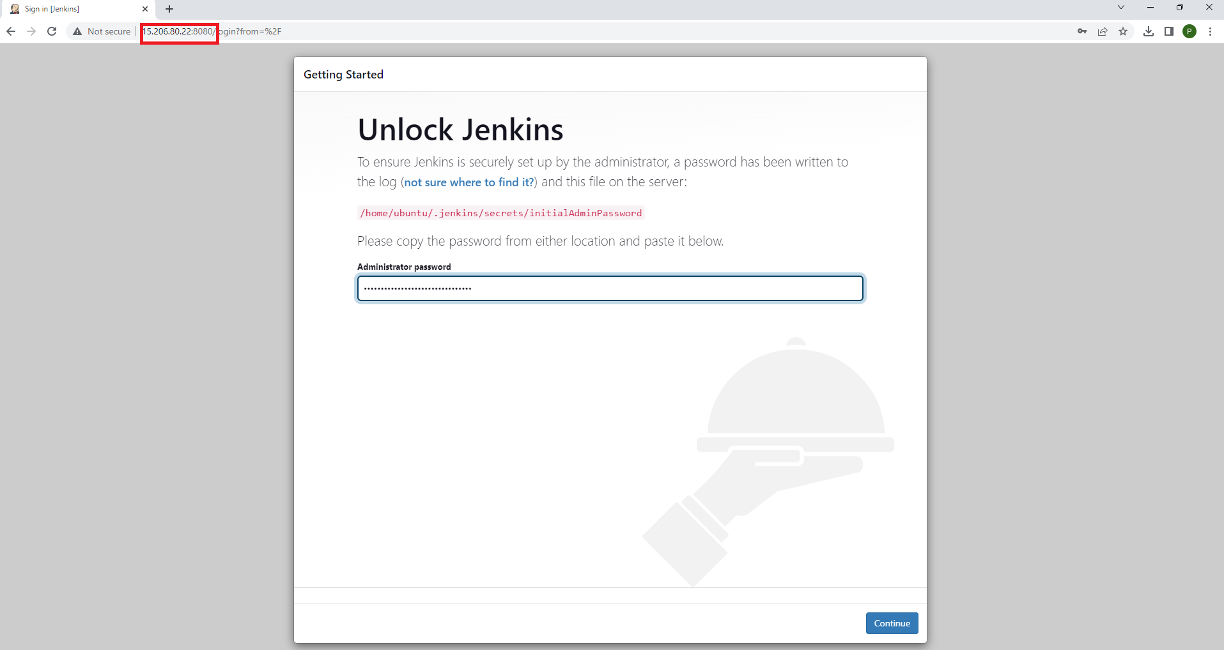

* Copy password from gitbash window and proceed.

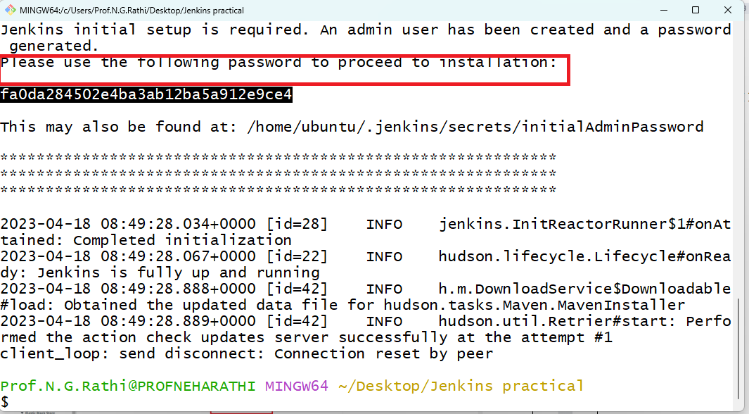

* Install suggested plug-ins.

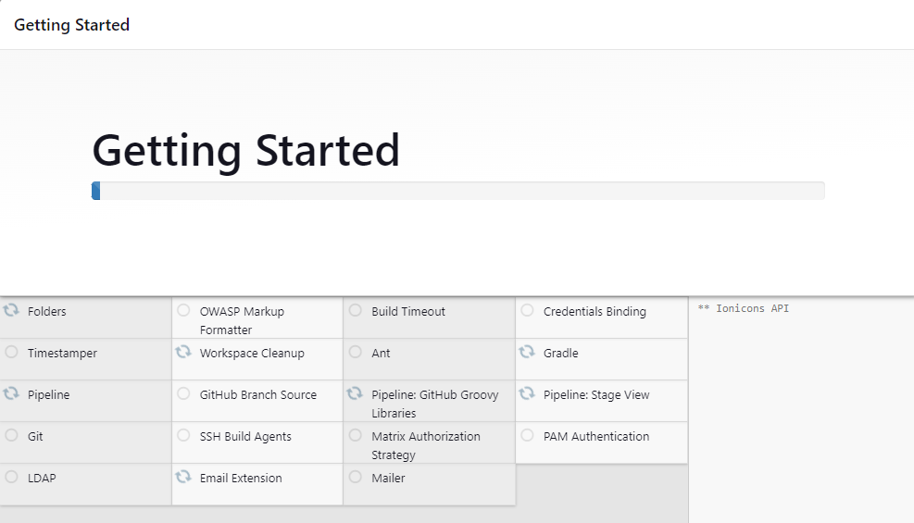

**Conclusion:** Thus I have installed and configured Jenkins with AWS for DevOps.